1. <https://github.com/in28minutes/MockitoTutorialForBeginners>
2. 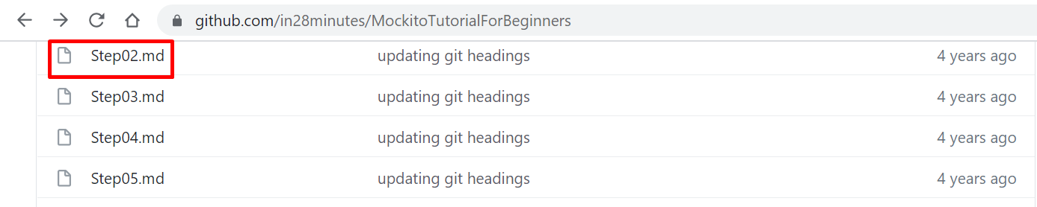
3. 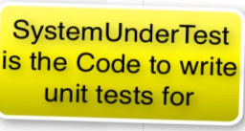
4. 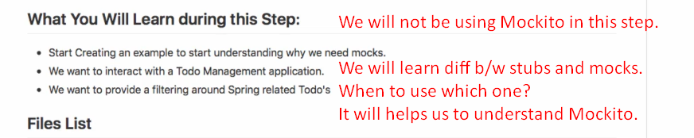
5. 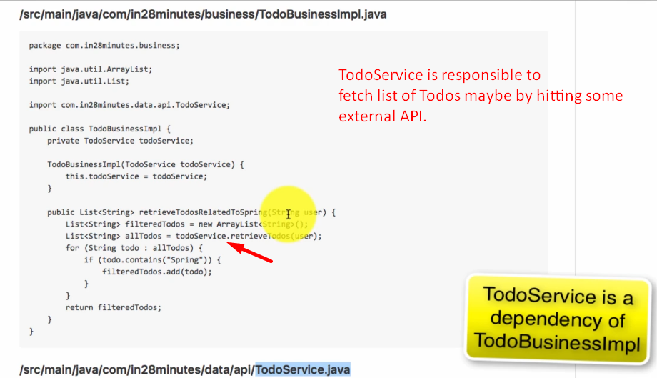
6. 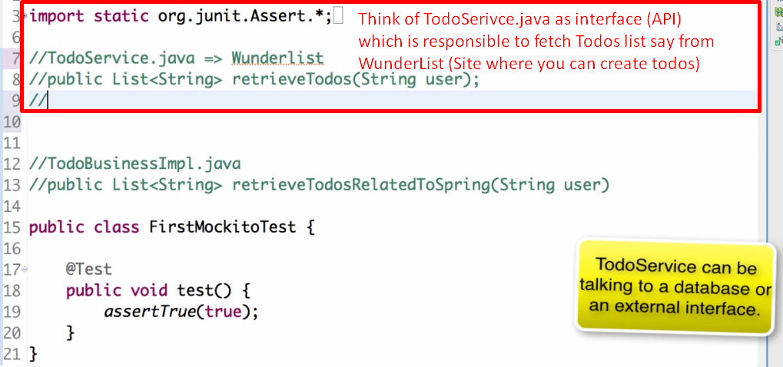
7. 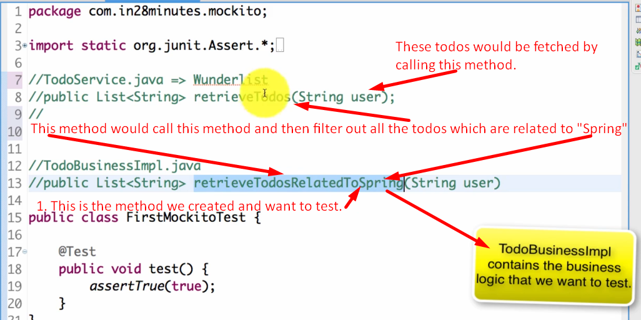
8. 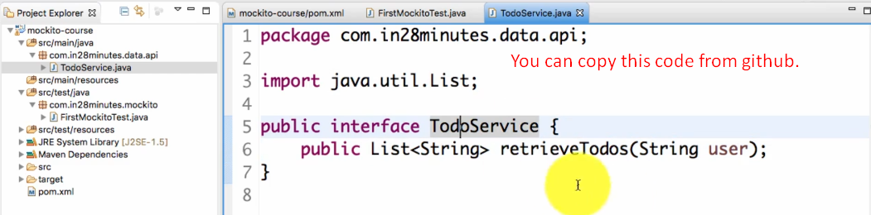
9. Let’s create TodoBusinessImpl.java   
   TodoService.java is dependency for TodoBusinessImpl.java  
   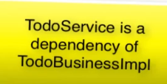
10. 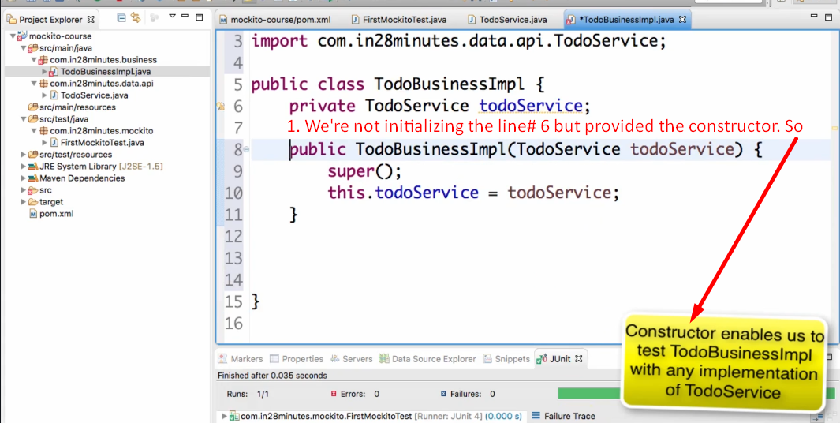
11. 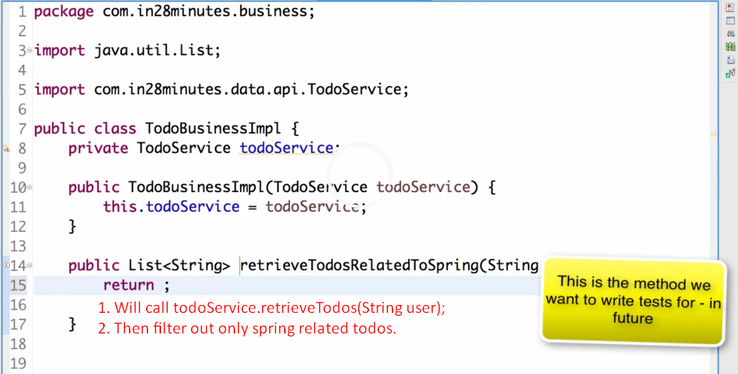
12. 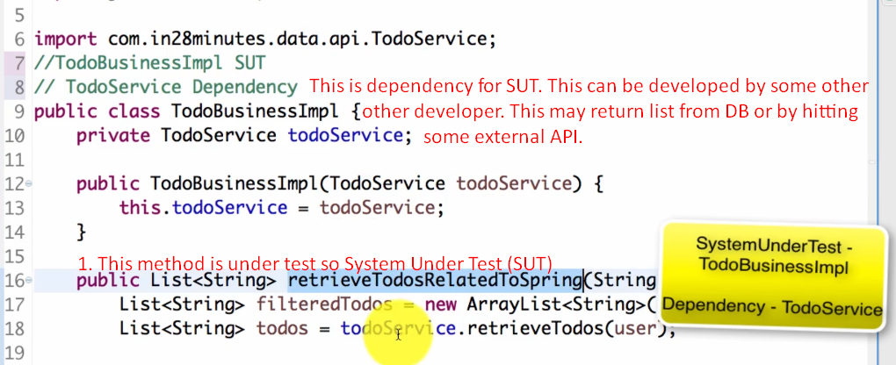**Let’s do this in next lec**:  
    